Docker-Challenge-2
Goal of the Exercise:
The goal of this exercise is to test your understanding of a Cloud Compute
deployment with Terraform.
You are tasked with creating a codebase for a microservice deployment on a
cloud environment, using Terraform. Since our focus is not the application
itself, the service will be a simple web server that returns a static page.
Requirements & Service Details:
•The service will be a simple web server that returns a static page.
•You can use apache2 or nginx to serve a simple HTML file.
•The service should be containerized and stored in a Docker
registry.
•The service should be deployed on a single VM instance as a docker
container.
•The image should be pulled from the registry specified earlier.
•The service should not be accessible from the internet but only
through a Load Balancer, except for SSH access from specific IP
addresses.
Deliverables:
You are to provide the following as part of your solution:
1. Docker file to build the image.
2. Terraform codebase to deploy the following:
Docker registry
VPC and all required networking resources
EC2 instance
Load Balancer
Notes:
•Since a CI/CD pipeline is not part of this exercise, we will work around
that with the help of Terraform.
•To push the image to the Docker registry, build the image locally
before running the Terraform code.
•Once the image registry is created, use Terraform to push the local
image to the registry.
•Similarly, use Terraform to pull the image from the registry and run
it on the VM instance once it is created.
•For SSH access:
--> Use a locally created key.
-->Add it to the cloud provider key storage.
--> Attach it to the instance.
•Use Terraform best practices for file structure and code
organization.
-->Use variables, locals, modules, etc. when appropriate.
•Include all tfvars, scripts, and other helper files used to deploy the
application.
•You may use any cloud provider of your choosing, although AWS is
preferred.
•Use a free tier account or a trial account to deploy the resources

Step 1: Project Setup and Prerequisites
Before starting, ensure you have the following installed on your machine:
•Docker
•Terraform
•AWS CLI (Configured with credentials that have administrative access)
Overview of the Challenge
The core objective is to deploy a simple, containerized web service on a
single AWS EC2 instance, making it accessible only via an AWS Load
Balancer. The entire infrastructure, from networking to the service
deployment, must be defined and managed using Terraform. A key
constraint is using Terraform not only for infrastructure but also for
managing the Docker image's lifecycle (building, pushing, pulling, and
running).
Terraform Codebase Structure
A standard, well-organized Terraform project uses a modular structure.
Here's how we'll lay out the files:

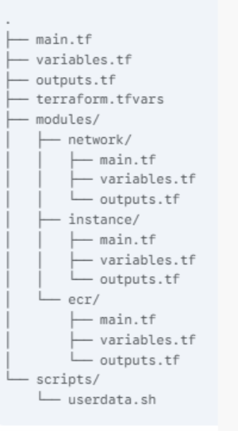

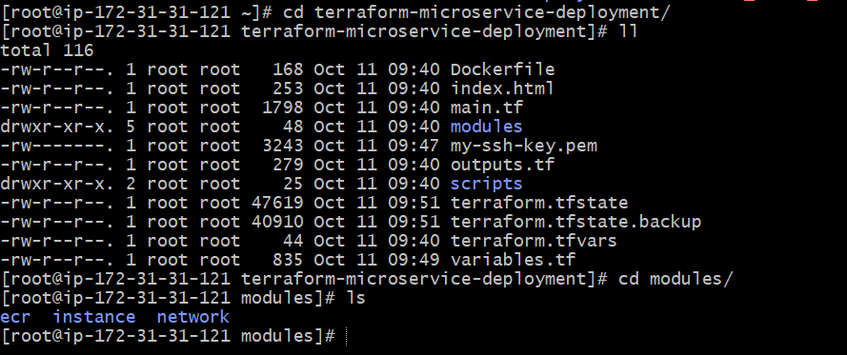

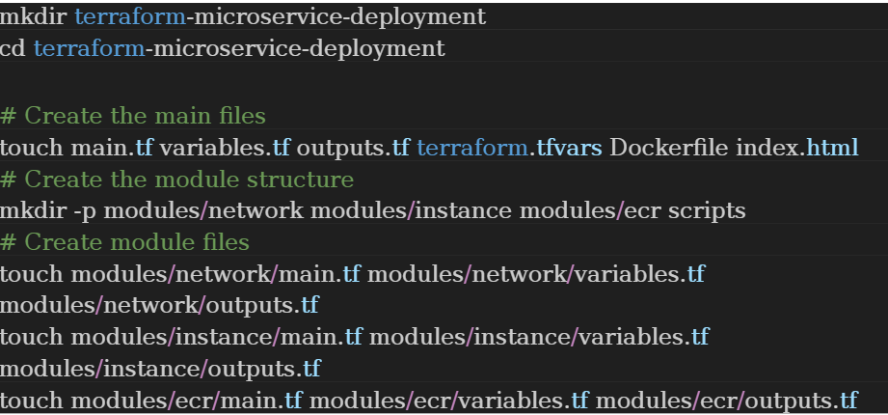
Step 2: Application Files (Service Details) :
Dockerfile
First, we need a simple web server application. This Dockerfile uses Nginx to
serve a static HTML page
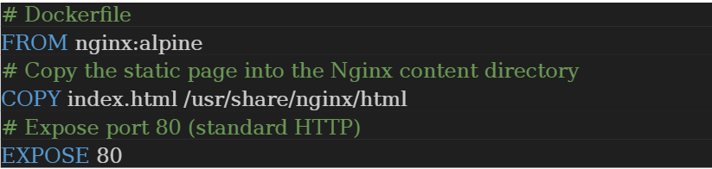
And the index.html file to go with it
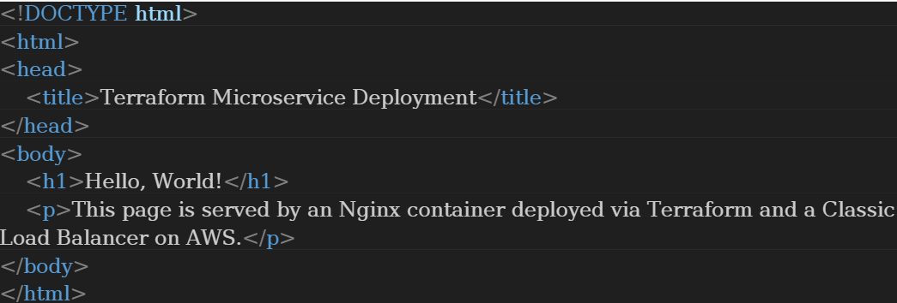

Step 3: Terraform Configuration Files:
•main.tf
This is the root module where we'll declare our AWS provider and call our
custom modules. It's the "orchestration" file

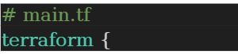
required_providers {
aws = {
source = "hashicorp/aws"
version = "~> 5.0"
}
# Required for local key generation
tls = {
source = "hashicorp/tls"
version = "~> 4.0"
}
# Required for local file output
local = {
source = "hashicorp/local"
version = "~> 2.0"
}
# Required for executing docker commands
null = {
source = "hashicorp/null"
version = "~> 3.0"
}
}
}
provider "aws" {
region = var.aws_region
}
# --- SSH Key Generation and Storage ---
resource "tls_private_key" "my_ssh_key" {
algorithm = "RSA"
rsa_bits = 4096
}
resource "local_file" "ssh_private_key" {
content = tls_private_key.my_ssh_key.private_key_pem
filename = var.ssh_key_path
file_permission = "0600"
}
resource "aws_key_pair" "generated_key_pair" {
key_name = "my-instance-key"
public_key = tls_private_key.my_ssh_key.public_key_openssh
}
# --- Module Orchestration ---
module "network" {
source = "./modules/network"
aws_region = var.aws_region
my_ip = var.my_ip
}
module "ecr" {
source = "./modules/ecr"
repository_name = "my-web-app-repo"
aws_region = var.aws_region
}
module "instance" {
source = "./modules/instance"
ami_id = var.ami_id
instance_type = var.instance_type
key_name = aws_key_pair.generated_key_pair.key_name
# Networking inputs
vpc_id = module.network.vpc_id
subnet_id = module.network.public_subnet_id
ssh_sg_id = module.network.ssh_sg_id
instance_sg_id = module.network.instance_sg_id
elb_id = module.network.elb_id
aws_region = data.aws_region.current.name
# Container/IAM inputs
ecr_registry_url = module.ecr.repository_url
instance_profile_name = module.ecr.instance_profile_name
}
data "aws_region" "current" {}
Variables.tf:
Define common input variables

# variables.tf
variable "aws_region" {
description = "The AWS region to deploy resources."
type = string
}
variable "ami_id" {
description = "The AMI ID for the EC2 instance (Amazon Linux 2)."
type = string
default = "ami-03c4f11b50838ab5d" # Check for a valid AMI in your region
}
variable "instance_type" {
description = "The instance type for the EC2 instance."
type = string
default = "t2.micro"
}
variable "my_ip" {
description = "Your public IP address for SSH access. (e.g., x.x.x.x/32)"
type = string
# IMPORTANT: REPLACE THIS WITH YOUR CURRENT PUBLIC IP ADDRESS FOR
SSH ACCESS
default = "54.163.203.81/32"
}
variable "ssh_key_path" {
description = "Path to save the generated SSH private key."
type = string
default = "./my-ssh-key.pem"
}
•Terraform.tfvars:
Set the desired AWS region
# terraform.tfvars
aws_region = "us-east-1"

outputs.tf (Root Directory)
Provide useful information after deployment
# outputs.tf
output "load_balancer_dns" {
description = "The DNS name of the Classic Load Balancer."
value = module.network.load_balancer_dns
}
output "ssh_private_key_file" {
description = "Path to the generated SSH private key."
Value = var.ssh_key_path
}

Step 4: Module Code
modules/ecr
This module manages the Docker Registry (ECR) and the fully automated
image build/push process.
•modules/ecr/main.tf:
This module provisions an Amazon Elastic Container Registry (ECR) repository
and handles the Docker image push. It also creates an IAM role and instance
profile for the EC2 instance to pull from the ECR

modules/ecr/main.tf
# 1. Create ECR Repository
resource "aws_ecr_repository" "web_app_repo" {
name = var.repository_name
image_tag_mutability = "MUTABLE"
image_scanning_configuration {
scan_on_push = true
}
}
# 2. Build the Docker image locally
resource "null_resource" "build_docker_image" {
# Trigger build before push
depends_on = [aws_ecr_repository.web_app_repo]
provisioner "local-exec" {
# '..' assumes Dockerfile and index.html are in the project root
command = "docker build -t my-web-app:latest ."
interpreter = ["/bin/bash", "-c"]
working_dir = "${path.module}/../../" # Run command from project root
}
}
# 3. Push the Docker image to ECR
resource "null_resource" "push_docker_image" {
depends_on = [
aws_ecr_repository.web_app_repo,
null_resource.build_docker_image
]
provisioner "local-exec" {
command = <<-EOT
# Get ECR login password and log in
aws ecr get-login-password --region ${var.aws_region} | docker login --username
AWS --password-stdin ${aws_ecr_repository.web_app_repo.repository_url}
# Tag the locally built image with the ECR URL
docker tag my-web-app:latest $
{aws_ecr_repository.web_app_repo.repository_url}:latest
# Push the image
docker push ${aws_ecr_repository.web_app_repo.repository_url}:latest
EOT
interpreter = ["/bin/bash", "-c"]
}
}
# 4. IAM Role for EC2 to Pull from ECR
resource "aws_iam_role" "ecr_role" {
name = "ec2-ecr-access-role"
assume_role_policy = jsonencode({
Version = "2012-10-17"
Statement = [
{
Action = "sts:AssumeRole"
Effect = "Allow"
Principal = {
Service = "ec2.amazonaws.com"
}
}
]
})
}
resource "aws_iam_role_policy_attachment" "ecr_policy" {
role = aws_iam_role.ecr_role.name
# Read-only access to ECR is sufficient for pulling
policy_arn = "arn:aws:iam::aws:policy/AmazonEC2ContainerRegistryReadOnly"
}
resource "aws_iam_instance_profile" "ecr_profile" {
name = "ec2-ecr-instance-profile"
role = aws_iam_role.ecr_role.name
}
Modules/ecr/variables.tf:
# modules/ecr/variables.tf
variable "repository_name" {
description = "Name for the ECR repository."
type = string
}
variable "aws_region" {
description = "The AWS region."
type = string
}
Modules/ecr/outputs.tf
# modules/ecr/outputs.tf
output "repository_url" {
description = "The full URL of the ECR repository."
value = aws_ecr_repository.web_app_repo.repository_url
}
output "instance_profile_name" {
description = "The name of the IAM Instance Profile for EC2."
value = aws_iam_instance_profile.ecr_profile.name
}
Modules/network:
This module creates the VPC, subnets, internet gateway, route tables, and
security groups. It also provisions a Classic Load Balancer.
→Modules/network/main.tf:
# modules/network/main.tf
# 1. VPC and Networking
resource "aws_vpc" "main" {
cidr_block = "10.0.0.0/16"
tags = { Name = "microservice-vpc" }
}
resource "aws_subnet" "public" {
vpc_id = aws_vpc.main.id
cidr_block = "10.0.1.0/24"
# Use a single AZ for simplicity with a single subnet
availability_zone = "${var.aws_region}a"
map_public_ip_on_launch = true
tags = { Name = "public-subnet" }
}
resource "aws_internet_gateway" "gw" {
vpc_id = aws_vpc.main.id
tags = { Name = "microservice-igw" }
}
resource "aws_route_table" "public" {
vpc_id = aws_vpc.main.id
route {
cidr_block = "0.0.0.0/0"
gateway_id = aws_internet_gateway.gw.id
}
tags = { Name = "public-route-table" }
}
resource "aws_route_table_association" "public" {
subnet_id = aws_subnet.public.id
route_table_id = aws_route_table.public.id
}
# 2. Security Groups
# SG for SSH access (restricted to your IP)
resource "aws_security_group" "ssh_sg" {
vpc_id = aws_vpc.main.id
name = "ssh-access-sg"
ingress {
from_port = 22
to_port = 22
protocol = "tcp"
cidr_blocks = [var.my_ip] # SSH only from your specified IP
}
egress {
from_port = 0
to_port = 0
protocol = "-1"
cidr_blocks = ["0.0.0.0/0"]
}
}
# SG for the Load Balancer (accessible from the internet)
resource "aws_security_group" "elb_sg" {
vpc_id = aws_vpc.main.id
name = "elb-internet-access-sg"
ingress {
from_port = 80
to_port = 80
protocol = "tcp"
cidr_blocks = ["0.0.0.0/0"] # HTTP access from anywhere
}
egress {
from_port = 0
to_port = 0
protocol = "-1"
cidr_blocks = ["0.0.0.0/0"]
}
}
# SG for the EC2 Instance (only accessible from the ELB and SSH SG)
resource "aws_security_group" "instance_sg" {
vpc_id = aws_vpc.main.id
name = "instance-internal-sg"
ingress {
from_port = 80
to_port = 80
protocol = "tcp"
security_groups = [aws_security_group.elb_sg.id] # HTTP only from the ELB
}
egress {
from_port = 0
to_port = 0
protocol = "-1"
cidr_blocks = ["0.0.0.0/0"]
}
}
# 3. Classic Load Balancer (ELB)
resource "aws_elb" "web_lb" {
name = "web-classic-lb"
subnets = [aws_subnet.public.id]
security_groups = [aws_security_group.elb_sg.id]
# Listener for external traffic (HTTP 80 -> HTTP 80 on instance)
listener {
instance_port = 80
instance_protocol = "http"
lb_port = 80
lb_protocol = "http"
}
# Basic Health Check
health_check {
target = "HTTP:80/"
interval = 30
timeout = 5
unhealthy_threshold = 2
healthy_threshold = 2
}
# Ensure the ELB waits for the instance to be ready
cross_zone_load_balancing = true
idle_timeout = 60
tags = {
Name = "Web-ELB"
} }
Modules/network/variables.tf:
# modules/network/variables.tf
variable "aws_region" {
description = "The AWS region."
type = string
}
variable "my_ip" {
description = "Your public IP address for SSH access."
type = string
}
→Modules/network/outputs.tf:
# modules/network/outputs.tf
output "vpc_id" {
description = "The ID of the VPC."
value = aws_vpc.main.id
}
output "public_subnet_id" {
description = "The ID of the public subnet."
value = aws_subnet.public.id
}
output "ssh_sg_id" {
description = "The ID of the SSH Security Group."
value = aws_security_group.ssh_sg.id
}
output "instance_sg_id" {
description = "The ID of the Instance Security Group."
value = aws_security_group.instance_sg.id
}
output "elb_id" {
description = "The ID of the Classic Load Balancer."
value = aws_elb.web_lb.id
}
output "load_balancer_dns" {
description = "The DNS name of the Classic Load Balancer."
value = aws_elb.web_lb.dns_name
}
•Modules/instance:
This module creates the EC2 instance and links it to the ELB.
→ Modules/instance/main.tf:
This module provisions the EC2 instance and runs a Docker
container on it using a user_data script.
# modules/instance/main.tf
resource "aws_instance" "web_server" {
ami = var.ami_id
instance_type = var.instance_type
subnet_id = var.subnet_id
key_name = var.key_name
associate_public_ip_address = true
iam_instance_profile = var.instance_profile_name
# Attach SSH SG (for user access) and Instance SG (for ELB access)
vpc_security_group_ids = [var.instance_sg_id, var.ssh_sg_id]
# Pass the ECR URL to the user_data script
user_data = templatefile("${path.module}/../../scripts/userdata.sh", {
ecr_url = var.ecr_registry_url
aws_region = var.aws_region # Ensure this variable is defined and passed
})
tags = { Name = "Web-Server-Instance" }
}
# Attach the instance to the Classic Load Balancer
resource "aws_elb_attachment" "web_lb_attachment" {
elb = var.elb_id
instance = aws_instance.web_server.id
}
•Modules/instance/variables.tf:
# modules/instance/variables.tf
variable "ami_id" {
type = string
}
variable "instance_type" {
type = string
}
variable "vpc_id" {
type = string
}
variable "subnet_id" {
type = string
}
variable "key_name" {
type = string
}
variable "ssh_sg_id" {
type = string
}
variable "instance_sg_id" {
type = string
}
variable "elb_id" {
type = string
}
variable "ecr_registry_url" {
type = string
}
variable "instance_profile_name" {
type = string
}
variable "aws_region" {
description = "The AWS region where resources are deployed (needed for ECR login
in user_data)."
type = string
}
→Modules/instance/outputs.tf:
# modules/instance/outputs.tf
output "instance_id" {
description = "The ID of the EC2 instance."
value = aws_instance.web_server.id
}
•Scripts/userdata.sh:
This script runs on the EC2 instance to set up Docker and run the container.
We use template file in modules/instance/main.tf to inject the ECR URL.
#!/bin/bash
# Log all output to a temporary file
exec > /tmp/user-data.log 2>&1
echo "Starting user data script..."
# 1. Update packages and install Docker and AWS CLI (needed for ECR login)
sudo dnf update -y
sudo dnf install -y docker aws-cli
# 2. Start Docker
sudo systemctl start docker
sudo systemctl enable docker
# Add the current user (ec2-user) to the docker group (takes effect on next login)
sudo usermod -aG docker ec2-user
sleep 15
# 3. CRITICAL FIX: Explicit ECR Authentication using IAM Role
echo "Authenticating Docker with ECR in ${aws_region}..."
# Get ECR login password and pipe it to docker login
aws ecr get-login-password --region ${aws_region} | sudo docker login --username
AWS --password-stdin "${ecr_url}"
if [ $? -ne 0 ]; then
echo "ERROR: Docker ECR login failed. Check IAM permissions and region."
exit 1
fi
# 4. Pull and run the container
echo "Attempting to run Docker container from ${ecr_url}:latest"
/usr/bin/docker run -d -p 80:80 "${ecr_url}:latest"
if [ $? -ne 0 ]; then
echo "ERROR: Docker run failed. Check container logs with 'docker logs <ID>'."
sudo docker ps -a
exit 1
fi
echo "User data script finished. Container should be running."
Step 5: Execution:
•Replace Placeholder:
•In variables.tf, replace the my_ip default with your public IP address in
CIDR format (e.g., "ip/32")
Initialize Terraform: Navigate to the root directory (terraform-
microservice-deployment) and run:
terraform init
•Validate and Plan: Check the plan to see all resources that will be
created
terraform plan
•Deploy Everything (Fully Automated): Run the single command
that performs the build, push, and deployment:
terraform apply --auto-approve
(Note: Using --auto-approve bypasses the manual confirmation step).
•Check in console

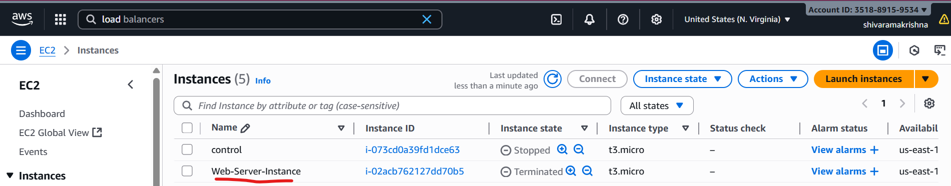

Loadbalancer:
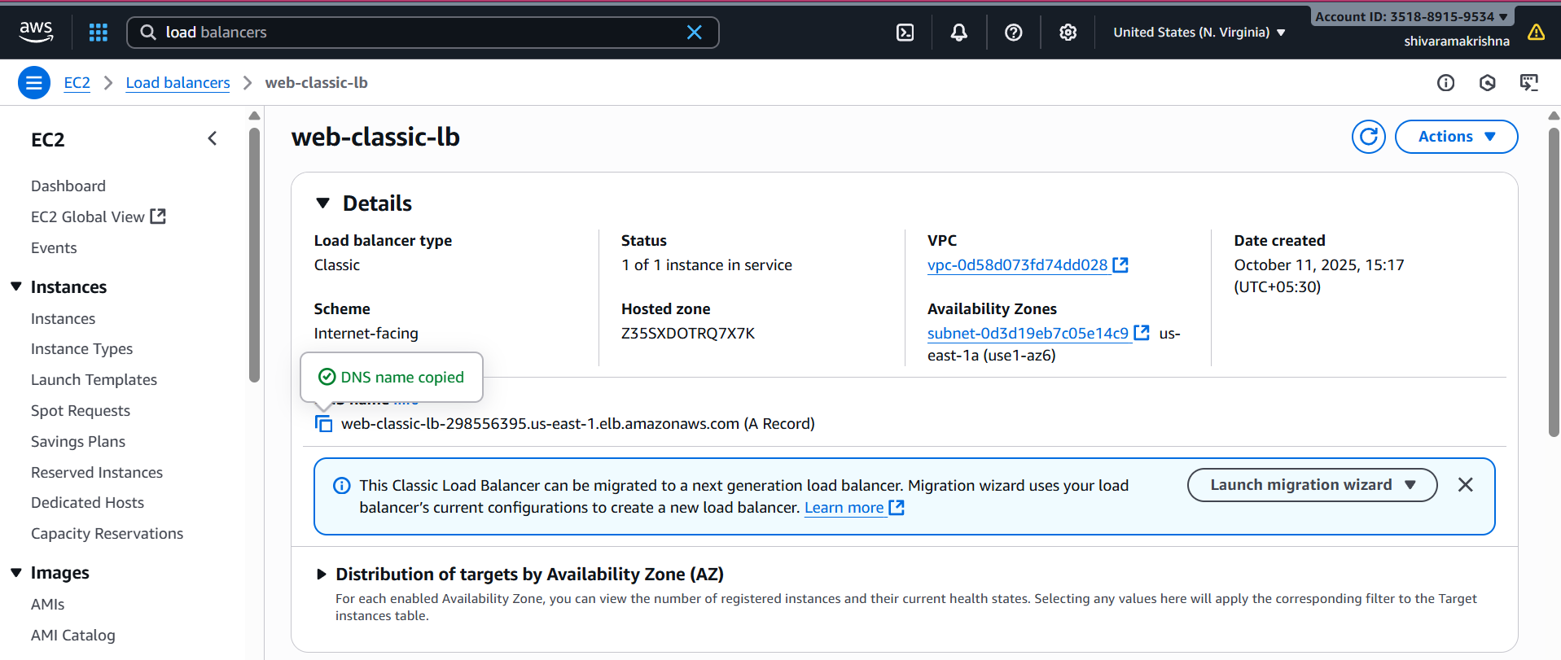

ECR:
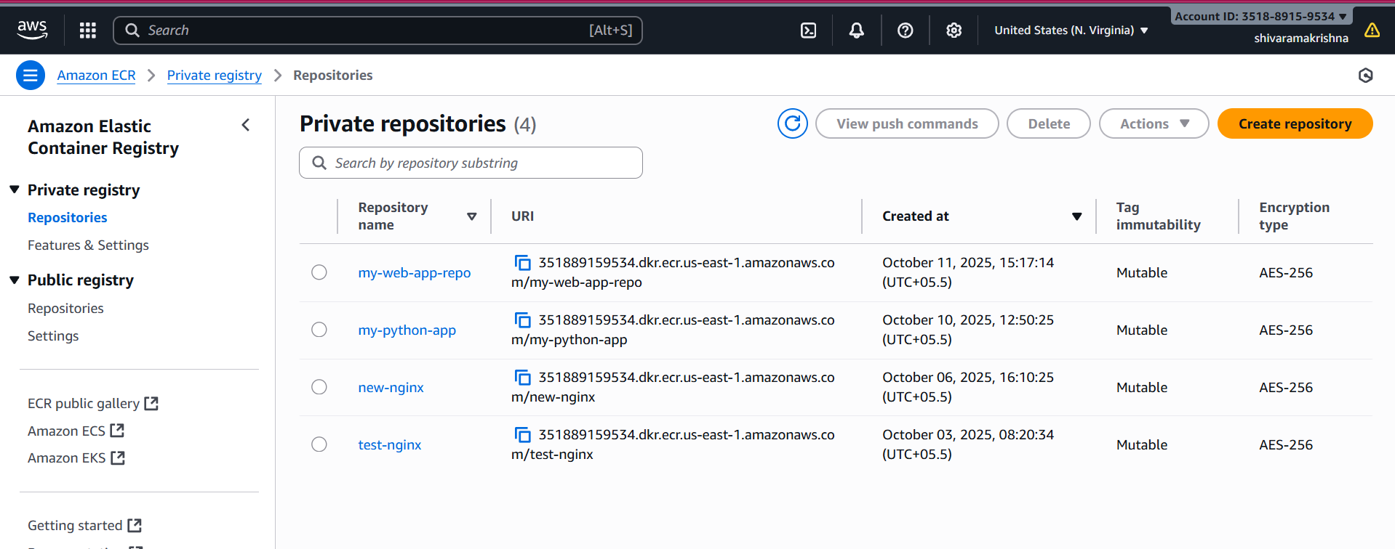

Check Docker images and running containers:
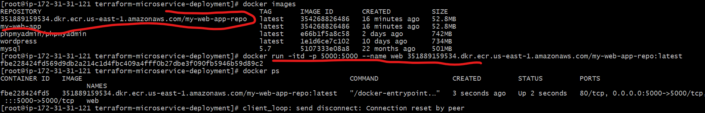

Testing:
